CTI LLM Fine-tuning Dataset Design

I.Cardei, 7/1/2025

Objective
Build a dataset that performs well on CTI-Bench. This can be extended to handle other CTI datasets, e.g. from Flashpoint or query.ai. The dataset will include (instruction, input, output) tuples with information about concepts and relationships, positive and negative examples.

Knowledge Bases
Gather information from the primary sources on techniques, tactics, groups, software, mitigations, examples, attack patterns, weaknesses, and vulnerabilities:
- MITRE ATT&CK (for now: just Enterprise). Main GitHub page, and Enterprise JSON file, mitreattack-python module
- CAPEC. Main Github page, STIX JSON file,
- CWE. JSON file.
- CVE. main page, GitHub page, mitre-cve-database,
- STIX. Doc page, Python module doc page, STIX2 Github.
- Proprietary: Flashpoint and others.

Schema Definition
Formalize the relationships and concepts identified in the CTI knowledge bases into a structured schema. This schema will guide the generation of diverse and relevant input/output pairs.

The schema needs to capture the entities and relationships within MITRE ATT&CK, CAPEC, CWE, and CVE that are relevant for generating CTI-Bench type questions.
Core Concepts (Entities):
- MITRE ATT&CK:
  - Tactic (e.g., Execution, Persistence, Exfiltration)
  - Technique (e.g., T1041 Exfiltration Over C2 Channel, T1548.004 Abuse Elevation Control Mechanism: Elevated Execution with Prompt)
  - Sub-Technique (e.g., T1548.004)
  - Mitigation (e.g., Multi-factor Authentication, Protocol Signatures)
  - Group (Threat Actor, e.g., UNC2452, Lazarus Group, Sandworm Team)
  - Software (Malware/Tool, e.g., Agent Tesla, AdFind, CoinTicker, MacDownloader, CheckVMX)
  - Data Source (e.g., Process Monitoring, Network Traffic, API Monitoring)
  - Component (e.g., API Monitoring, Process Command-line)
  - Platform (Enterprise, Mobile, ICS, Cloud)
  - Procedure Example (Specific instance of a technique used by a group/software, e.g., 2015 Ukraine Electric Power Attack)
  - Targeted Asset (in ICS, e.g., HMI, PLC)
- CAPEC (Common Attack Pattern Enumeration and Classification):
  - Attack Pattern (e.g. CAPEC-36: Using Unpublished Interfaces or Functionality)
  - Attack Category (e.g., Client-Side Attacks, Network Attacks)
  - Consequence (e.g., Information Disclosure, Arbitrary Code Execution)
- CWE (Common Weakness Enumeration):
  - Weakness (e.g. CWE-293: Using Referer Field for Authentication)
  - Impact (e.g., Information Exposure, Arbitrary Code Execution, Loss of Confidentiality/Integrity)
  - Phase (Development Lifecycle Phase, e.g., Design, Implementation)
  - Mitigation Strategy (General approaches to address weaknesses)
- CVE (Common Vulnerabilities and Exposures):
  - Vulnerability (Specific instance of a weakness, often linked to software versions)
  - Exploit (Specific code or technique used to take advantage of a vulnerability, e.g., DirtyCow)
  - Impact

Schema Diagram

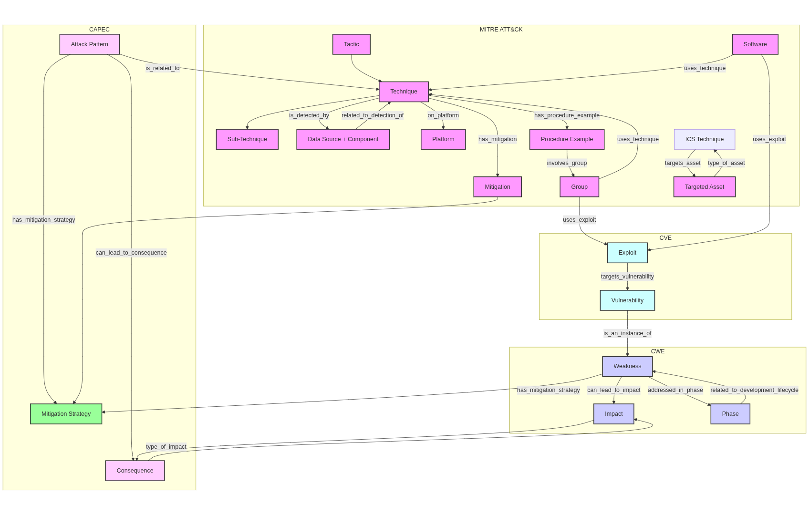Figure 1: MITRE ATT&CK, CAPEC,CVE , and CWM schema and relationships.

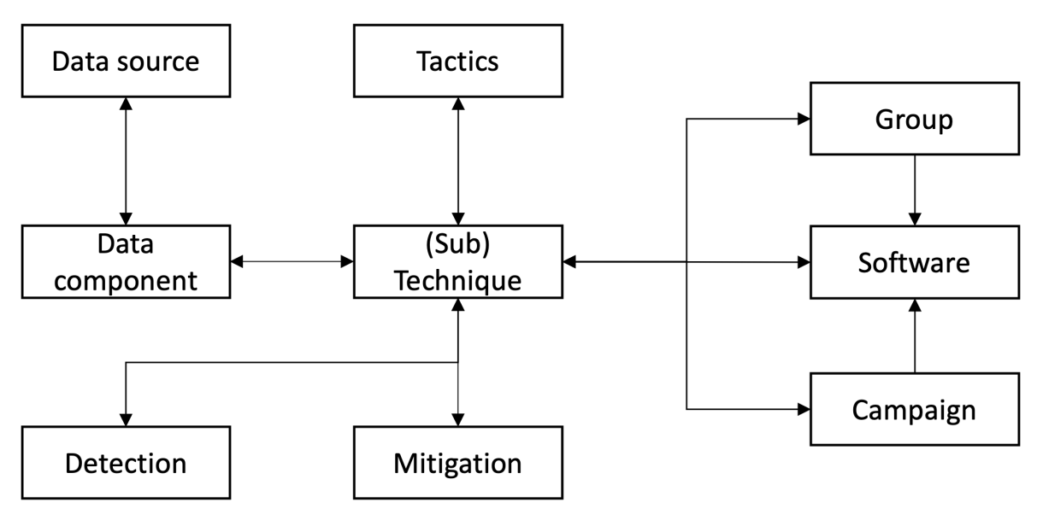Figure 2: MITRE ATT&CK schema from Cyberpal.AI paper.

Training Dataset Triple Generation Methodology

For the implementation one can use a web template engine, such as Django.
Use schema and follow these steps:

1. Define question templates for (instruction, input, output) triples.
- Write a set of diverse instruction templates for each type of question that can be asked based on the schema.
  - Follow specific CTI-LLM sample questions/template to satisfy Athena SG use cases.
  - Follow CTI-Bench MCQ (initially, then RCM, TAA, VSP, ATE) and other benchmark categories.

2. Extract information using templates and information from knowledge bases:
- automated, using mitreattack-python and STIX2 Python modules:
  - For each ATT&CK Technique, extract its ID, name, associated tactics, mitigations, groups, software, data sources, and platforms.
  - For each CAPEC, extract its ID, name, related techniques, and consequences.
  - For each CWE, extract its ID, name, potential impacts, and recommended phases/mitigations.
  - For CVEs, link them to CWEs and identify associated exploits/malware.
- manually curated: for more complex questions, if needed.

3. Generate input strings from templates.
- For each selected template, pick a random [key entity] placeholders, then traverse the concept graph, extract all other [entity] placeholders (at random if multiple choices) and generate input strings.
- Example template: "What is the specific [MITIGATION] suggested in MITRE ATT&CK [key TECHNIQUE_ID] to prevent [THREAT_ACTION]?". Actions:
  - Pick a random Technique (e.g., T1041).
  - Retrieve its associated Mitigation (e.g., Protocol Signatures).
  - Derive or infer the THREAT_ACTION from the technique's description (e.g., "exfiltration over C2 channels").
  - Construct the input string.

4. Generate the output strings from templates.
- Based on the entities selected for the input, directly retrieve the correct answer from the knowledge base. This is the "ground truth" for fine-tuning.
- Example: If T1041 and "Protocol Signatures" were chosen for the input, the output is "Protocol Signatures".

5. Generate Negative Examples (distractors):
- To show the LLM what something is not for defining clearer boundaries between nearby concepts. This makes the model more robust.
- Reduce over-generalization that leads to hallucinations.
- Generate several plausible but incorrect distractors to ground the model. This is crucial for MCQ performance.
- Method TBD.

6. Generate the fine-tuning triples:
- Associate the proper prompt instruction with the generated input/output pairs.
- Generate strings.

Sample Input/Output templates from CTI-Bench MCQ:
Gemini is very useful to create these templates that capture a number of CTI-Bench MCQ questions. A flexible template engine should easily be able to accommodate different data models / KBs, including proprietary ones.
Here are the templates:
- "What is the specific [MITIGATION/DEFENSE] suggested in MITRE ATT&CK [TECHNIQUE_ID] to prevent [THREAT_ACTION]?" (Output: Mitigation Name)

- "Which of the following threat actors have been known to use [TECHNIQUE_NAME] for [TACTIC] during [EVENT_NAME]?" (Output: Group Name)

- "Which [KNOWLEDGE_BASE] [ENTITY_TYPE] is described by [DESCRIPTION]?" (Output: Entity Name/ID)

- "Which mitigation is recommended for preventing [RISK] by enforcing [MEASURE]?" (Output: Mitigation Name)

- "In the context of MITRE ATT&CK for [PLATFORM], which of the following best describes the primary risk associated with [TECHNIQUE_ID]?" (Output: Description of Risk/Impact)

- "Which related attack pattern specifically pertains to [ATTACK_DESCRIPTION]?" (Output: CAPEC ID/Name)

- "What is a common consequence of [CWE_ID]?" (Output: Impact/Consequence)

- "Which data source and component combination is suggested for detecting the technique [TECHNIQUE_ID]?" (Output: Data Source: Component)

- "During which phase should [ACTION] be performed to prevent [CWE_ID]?" (Output: Phase Name)

- "Analyze the provided scenario and identify the attack performed on the client organization." (Input: Detailed scenario, Output: Attack Name)

